**Tasks Description:**

1. Create a directory called "my_folder", navigate into it, and create a file named "my_file.txt" with some text. Then, create another file named "another_file.txt" with some text. Concatenate the content of "another_file.txt" to "my_file.txt" and display the updated content. Finally, list all files and directories in the current directory.
2. Create 20 files with .txt extensions and rename the first 5 files to.yml extension and print the latest created top 5 files among the total no of files".

**Task 1 Solution:**

[root@ip-10-173-68-172 summaryextract]# mkdir my_folder  
[root@ip-10-173-68-172 summaryextract]# cd my_folder/  
[root@ip-10-173-68-172 my_folder]# echo "This is some Text" > my_file.txt  
[root@ip-10-173-68-172 my_folder]# echo "This is some another Text" > another_file.txt  
[root@ip-10-173-68-172 my_folder]# cat another_file.txt >> my_file.txt  
[root@ip-10-173-68-172 my_folder]# cat my_file.txt  
This is some Text  
This is some another Text  
[root@ip-10-173-68-172 my_folder]# ls -l  
total 8  
-rw-r--r-- 1 root root 26 Apr 21 07:37 another_file.txt  
-rw-r--r-- 1 root root 44 Apr 21 07:38 my_file.txt

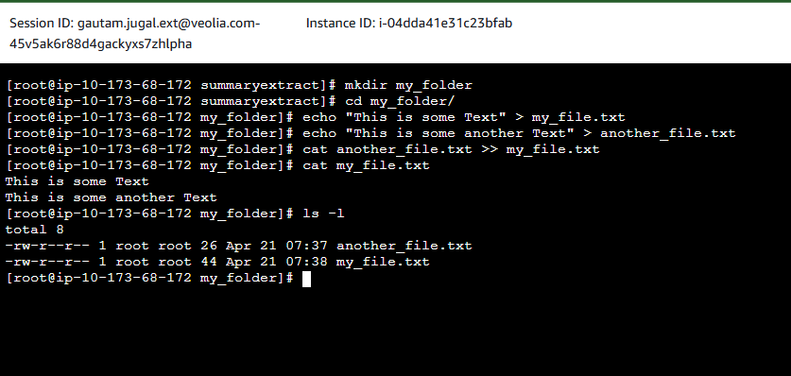

**Task 2 Solution:**

[root@ip-10-173-68-172 my_folder]# for i in {1..20}; do touch task2_file$i.txt; sleep 0.1; done  
You have mail in /var/mail/root  
[root@ip-10-173-68-172 my_folder]# for i in {1..5}; do mv task2_file$i.txt task2_file$i.yml;  
done  
[root@ip-10-173-68-172 my_folder]# ls -lt | head -n 6 | tail -n 5  
-rw-r--r-- 1 root root 0 Apr 22 08:35 task2_file20.txt  
-rw-r--r-- 1 root root 0 Apr 22 08:35 task2_file19.txt  
-rw-r--r-- 1 root root 0 Apr 22 08:35 task2_file18.txt  
-rw-r--r-- 1 root root 0 Apr 22 08:35 task2_file17.txt  
-rw-r--r-- 1 root root 0 Apr 22 08:35 task2_file16.txt

[root@ip-10-173-68-172 my_folder]#

**Note\*** I have used sleep 0.1 to make file creation time different as for loop gives same time while running and it will not be possible to sort correctly

